**Resume**

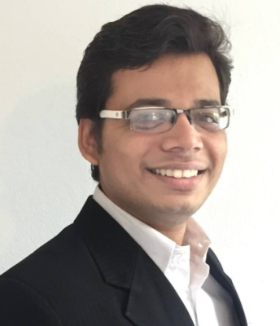**Personal Details**

Name Prithvi Prakashkumar Patel

Address Vogteistraße 5,

88250 Weingarten

Mobile +4917640445531

E-Mail prithvi14091996@gmail.com

DOB/POB 14.09.1996 / Ahmedabad, Indien

Nationality Indisch

**Education**

**Since 08/2020 M.E., Electrical and Embedded Systems**

Focus AI, Computer Vision, Automotive Systems

Hochschule Ravensburg Weingarten

Weingarten, 88250 Deutschland

**03/2016 – 08/2020 B.E., Electrical and Information Technology**

Focus Automation Technology, Networking

Hochschule Ravensburg Weingarten

Weingarten, 88250 Deutschland

**Experience**

**04/2020 - Now** **Master Thesis : Analysis and evaluation of the need of generic and scalable Cloud-based OTA update system**

* Design of a new generic and scalable architecture for OTA updates, which can be applied to various sectors

Soluware GmbH, Ravensburg

**02/2020 – 02/2022** **Working Student - Software Engineer**

* Xamarin Apps, WPF apps and backend development in .NET framework and .NET core
* Test Automation, Code Refactoring, Debugging and Building Tools

Soluware GmbH, Ravensburg

**Hands-on Projects**

**12/2021 – 02/2022 AkaFLASH tool (Company Project)**

* Backend Web API, which processes user/configuration data and stores/retrieves from/to database.
* .NET framework, C# for the Backend API, WPF as Client app and MySQl for the phpMyAdmin Database.

**03/2021 – 08/2021** **Womega E-Commerce Full Stack Web App**

* FullStack Ecommerce WebApp that allows customers to browse through clothes, add them to cart and pay with credit/debit cards. This project includes an admin portal to maintain products, company analytics and perform business activities.
* .NET Core for Backend, HTML, Bulma CSS and VueJs for Frontend and local database.

Github: <https://bit.ly/3mAld4p>

**05/2021 – 06/2021** **Restaurant Robot**

* Robot Algorithm Development, where the robots picks up the dish from kitchen as the event is triggered, navigates to the table from which the order came from and and keeps the dish on the table
* Developed Python, Simulated in Gazebo, ROS framework and Docker Containers.

Github: <https://bit.ly/3zsOLso>

**Technical skills**

**Programming Languages** C, C++ for Graphics and Embedded programming,

JAVA – Android Studio, Swing, Linux command line, Git and Gitlab for version control, Meld

C# for Xamarin, WPF und Web API .Net Framework, und .Net Core MVC – MVVM Web Application, C++, Python (ROS), VueJs (Javascript)

Software IDE Code :: Blocks, Netbeans IDE, Eclipse IDE, Design Suite,

Atom IDE, Microsoft Office: Word, Powerpoint, Excel und Access, AutoCAD 2015 mit Autodesk Professional Certificate,

Visual Paradigm UML-Tool, Visual Studio., C#, Android Studio, Visual Studio Code

**Languages**

German Good Knowledge (B2)  
English Fluent in speaking and writing   
Gujarati Native

**Hobbies and Leisure activities**

Indie Game Development, Listening Music, Book Reading

Weingarten, 19.06.2022

Prithvi Patel